**Module-2: GIT Assignment – 2**

Do the following tasks:

● Create a git working directory with feature1.txt and feature2.txt in the master branch

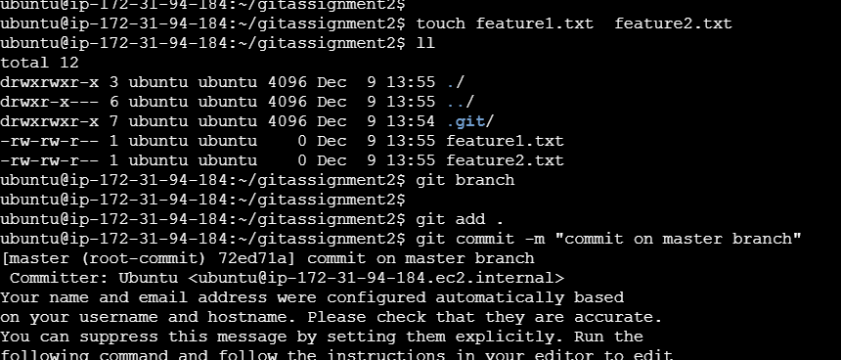

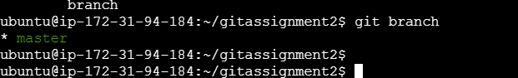

● Create 3 branches develop, feature1 and feature2



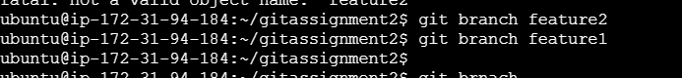

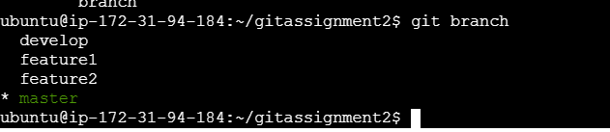

● In develop branch create develop.txt, do not stage or commit it

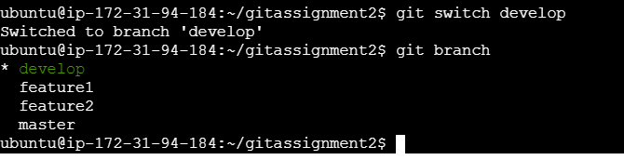

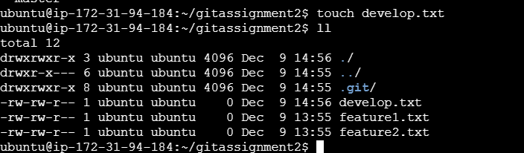

● Stash this file, and checkout to feature1 branch

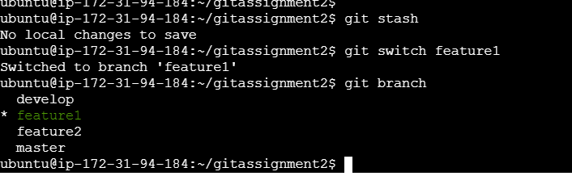

● Create new.txt file in feature1 branch, stage and commit this file

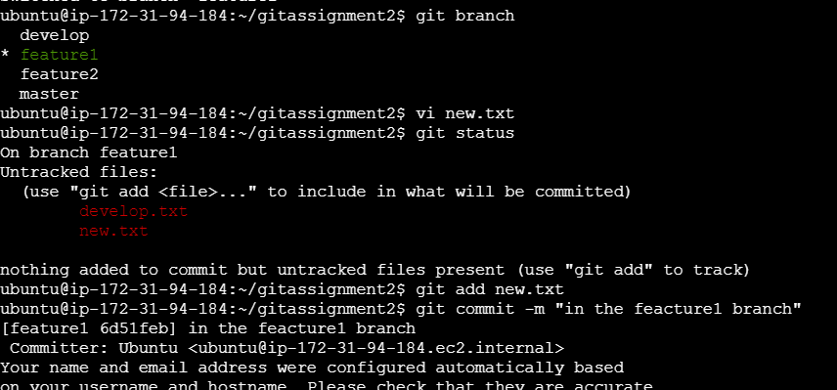

● Checkout to develop, unstash this file and commit

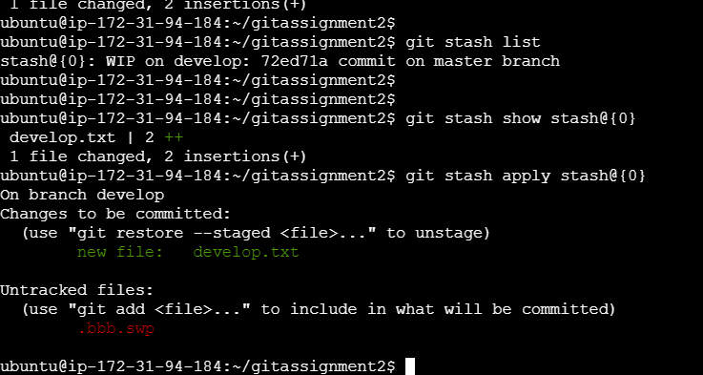

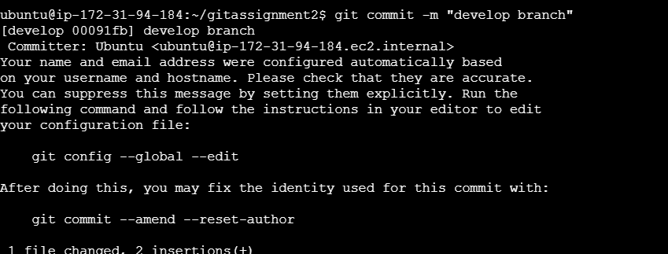

Please submit all the git commands used to do the above steps